CERTIFICATE OF LEGITIMACY

is given to

**ABDUL KHALIQ POTAWAN**

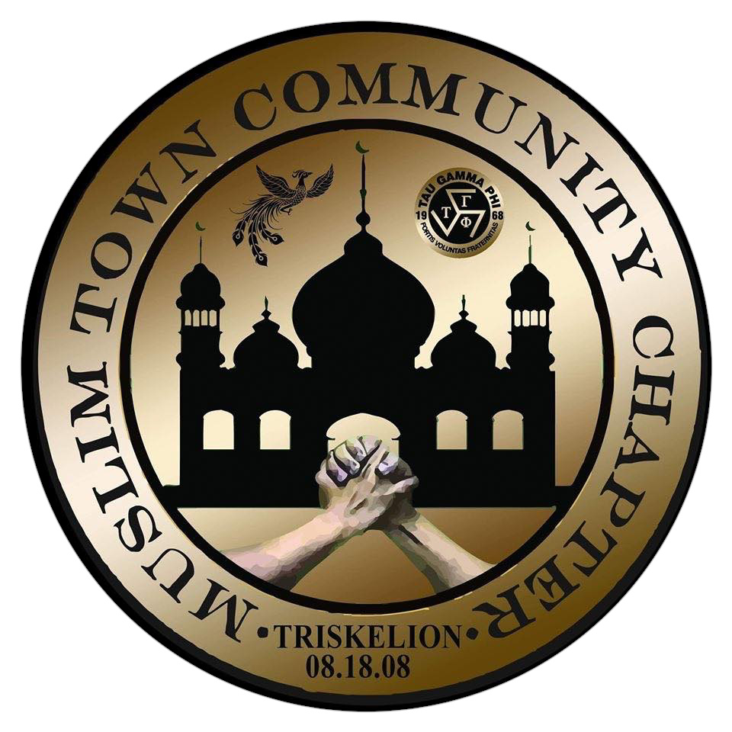undergo and survived the **Traditional Initiation Rites** of **TAU GAMMA PHI Triskelion Grand Fraternity** , with fraternal info and all the rights and privilege entitled.

FRATERNAL INFORMATION

ALEXIS NAME : ABET

TRISKELION BIRTH : November 26, 2017

BATCH NAME : Golden Boys

CHAPTER : Muslim Town Community Chapter

LOCATION : Quiapo Manila

GRAND TRISKELION : Brod. Omar Sharief

MWW/MI : Brod. Abubacar Sharief

WITNESS OF I.R. : Brod. Hussein Mauga

: Brod. Darr Alcala

: Brod. Tandoy Macapundag

This certification is issued upon his request for legality and whatever purpose it may serve.

Given this 4th Day of August year 2021 at **Muslim Town Community Chapter**

Certified by:

Brod. OMAR “MHAR” SHAREIF Brod. JAMAL “JAM”DIMAKUTA

Former Grand Triskelion /MTCC-founder chapter MLQU 99’mdg/MTCC-founder chapter/Adviser

Brod. DARR “DAR” ALCALA Brod. JAL-NOR “NYJ” MAUGA

Master Keeper of the Scroll INFOCOM

Brod. ENGR. RIKKI “AGILA” SALANDA

Grand Triskelion

Brod. JAL-NOR “NYJ”MAUGA

mtcc-INFOCOM